Hybrid Vector Search and Knowledge Graph Retrieval for
Clinical Question Answering
Harshit Kapur, Sabah Mohammed and Jinan Fiaidhi
Department of Computer Science, Lakehead University
Thunder Bay, Ontario, Canada
Abstract
Retrieval-Augmented Generation (RAG) and knowledge-graph augmentation are widely proposed to address the frozen, and potentially outdated, parametric knowledge of large language models (LLMs) in clinical question answering. This paper investigates whether such augmentation improves clinical reasoning over an unaugmented baseline, evaluating a progression of five architectures — a no-retrieval baseline, flat-vector RAG, static GraphRAG, agentic GraphRAG with confidence-gated self-correction, and a dynamic variant that updates the knowledge graph from live PubMed literature — on the complete 1,273-question MedQA-USMLE benchmark. Contrary to the motivating hypotheses, no retrieval- or graph-augmented configuration outperforms the parametric baseline (77.1%). Flat-vector RAG is statistically indistinguishable from the baseline (76.7%, McNemar p = 0.65), while all three graph-based systems perform significantly worse (73.1–74.2%, p < 0.01). Scaling the knowledge graph twenty-fold, from 50 to 1,000 source documents, does not recover this deficit, indicating that the shortfall is not attributable to insufficient graph size but to the redundancy of injected context when the base model already encodes the benchmark's knowledge. A domain-focused analysis nevertheless reveals a conditional effect: within pharmacology (598 questions), the dynamic PubMed system's significant deficit relative to the baseline disappears (p = 0.12), indicating that live literature retrieval is most competitive precisely where current, structured knowledge is densely represented in the retrieved evidence. We report these results as a cautionary, statistically grounded account of when retrieval and graph augmentation help — and when they do not — in clinical question answering, and outline directions, including evaluation on post-training-cutoff knowledge and stage-wise retrieval metrics, for a more rigorous future test of the underlying hypotheses.
Index Terms—Agentic GraphRAG, Retrieval-Augmented Generation, Knowledge Graphs, Clinical Question Answering, Large Language Models, MedQA, PubMed, Self-Correction
I. INTRODUCTION
Large Language Models have demonstrated impressive linguistic and reasoning capabilities across a wide range of benchmarks, yet they exhibit a fundamental structural limitation in high-stakes clinical domains: their knowledge is encoded implicitly in model weights and frozen at the point of pre-training [1]. This renders LLMs unable to reflect the continuous evolution of medical literature—new drug approvals, revised dosing guidelines, emerging resistance patterns, and updated diagnostic criteria—that defines the operational reality of evidence-based medicine [2]. Operating as probabilistic sequence generators, LLMs prioritize linguistic fluency over factual veracity, and can produce hallucinations that are clinically plausible but factually dangerous when the model is queried at the boundaries of its parametric knowledge. For clinical question answering, where the difference between the correct drug and a plausible alternative can be a matter of patient safety, this bottleneck is not a technical inconvenience—it is a fundamental barrier to deployment. The central research problem this paper addresses is the insufficient precision of standard retrieval methods for clinical reasoning. To investigate this, we examine the following hypothesis: that augmenting LLMs with hybrid retrieval—combining real-time knowledge graph traversal and vector-based evidence retrieval—will yield clinical question-answering outputs that are simultaneously more factually current, more structurally precise in their reasoning chains, and better calibrated in their uncertainty expression than those produced by either unaugmented LLMs or single-strategy retrieval baselines.
The most widely adopted approach to addressing the LLM knowledge bottleneck, besides fine-tuning and prompt engineering, is Retrieval-Augmented Generation (RAG), in which semantically similar passages from an external, updatable corpus are retrieved at inference time and prepended to the LLM prompt [4]. RAG decouples knowledge currency from model weights, reducing hallucination in knowledge-intensive tasks and enabling the LLM to reason over evidence outside its training distribution without retraining or fine-tuning. However, retrieval precision remains a persistent and systematic weakness of flat-vector RAG: a passage that scores highly on embedding similarity may be topically related to a clinical query while containing none of the specific causal reasoning required to answer it. In expert domains such as medicine, this retrieval noise is not a minor inconvenience—prior work has documented that standard RAG can perform worse than no retrieval at all when the retrieved context is misleading rather than informative [3]. Flat-vector RAG thus addresses the currency problem but introduces a new one: it cannot guarantee that what it retrieves is clinically relevant, only that it is semantically proximate. Addressing the central research problem of this paper therefore requires evaluating three constituent sub-hypotheses. First, the Comparative Efficacy Hypothesis posits that implementing a RAG framework integrated with a dynamic medical ontology will yield statistically significant improvements in structural precision and clinical accuracy over zero-shot baseline models. Second, the Uncertainty-Awareness Hypothesis posits that augmenting an LLM with a probabilistic uncertainty-quantification layer will increase the proportion of uncertainty-aware clinical outputs without compromising factual correctness. Third, the Temporal-Relevance Hypothesis posits that providing clinicians with LLM outputs augmented by both real-time evidence retrieval and structured chain-of-thought logic will lead to greater diagnostic accuracy and better-calibrated clinical confidence than unaugmented LLMs.
A second research direction for addressing the LLM knowledge bottleneck tackles retrieval noise directly, by replacing unstructured passage retrieval with structured graph traversal, and in doing so provides the empirical foundation for evaluating the Comparative Efficacy Hypothesis. Knowledge Graph-augmented RAG (GraphRAG) represents clinical entities—diseases, symptoms, medications, procedures, and mechanisms—along with their typed relationships as explicit graph nodes and edges, enabling retrieval that is structurally relevant rather than merely semantically similar [5]. Each retrieved subgraph carries a relational specificity that a raw text chunk cannot match: not merely that metformin co-occurs with diabetes in a passage, but that metformin treats type 2 diabetes mellitus, is contraindicated in renal impairment, and is indicated as first-line therapy under specific clinical conditions. This structured precision is intended to make graph-augmented retrieval more robust to the noise that can degrade flat-vector RAG in clinical settings, motivating the hypothesis that a RAG framework integrated with a dynamic medical ontology will improve structural precision and clinical accuracy over zero-shot baseline models. However, static knowledge graphs introduce a different and equally serious limitation: a graph constructed once from a fixed corpus becomes unreliable as the evidence base shifts, returning confident but outdated facts that current literature would contradict. GraphRAG addresses retrieval noise but not staleness; a static graph is, in effect, a frozen index by another name.
A third and more ambitious research direction reconceptualizes the LLM not as a passive consumer of retrieved context but as an active reasoning agent that dynamically constructs, updates, and traverses knowledge graphs—and in doing so targets the staleness limitation that underpins the Temporal-Relevance Hypothesis. In Agentic GraphRAG[ref], LLM agents act as dynamic reasoning engines that interact iteratively with graph structures rather than performing one-shot retrieval over a static index [7]. Frameworks such as Agentic Medical Graph-RAG (AMG-RAG) deploy LLM agents that continuously extract biomedical entities and relations from newly published literature—including PubMed abstracts and medical textbooks—annotating each edge with confidence scores and provenance metadata, thereby aiming to keep the underlying graph aligned with the current state of medical knowledge rather than a historical snapshot of it [6]. This autonomous, literature-driven update mechanism is designed to eliminate the manual curation bottleneck, and it motivates the hypothesis that LLM outputs augmented by real-time evidence retrieval will achieve greater diagnostic accuracy and better-calibrated clinical confidence than unaugmented LLMs.
Agentic GraphRAG further targets the uncertainty limitation that underpins the Uncertainty-Awareness Hypothesis through self-correcting reasoning loops tied to confidence estimation. When a reasoning path over the knowledge graph yields low confidence, the agent adapts its graph traversal strategy or triggers external search queries to cross-verify facts before committing to an answer [6]. This deliberative, self-correcting behavior is intended to simulate the iterative hypothesis revision of expert clinical reasoning, and it motivates the hypothesis that augmenting an LLM with a probabilistic uncertainty-quantification layer will increase the proportion of uncertainty-aware clinical outputs without compromising factual correctness.
Taken together, continuous graph updating and confidence-driven self-correction are designed to address both failure modes—staleness and noise—that neither flat-vector RAG nor static GraphRAG can jointly resolve. Prior work on AMG-RAG has reported that this combination, even with a relatively lightweight model, can surpass systems orders of magnitude larger in parameter count on the MedQA benchmark [6]. It is precisely this convergence of currency, structural precision, and uncertainty-awareness that defines the central hypothesis of this paper and that the three sub-hypotheses above are designed to evaluate empirically.

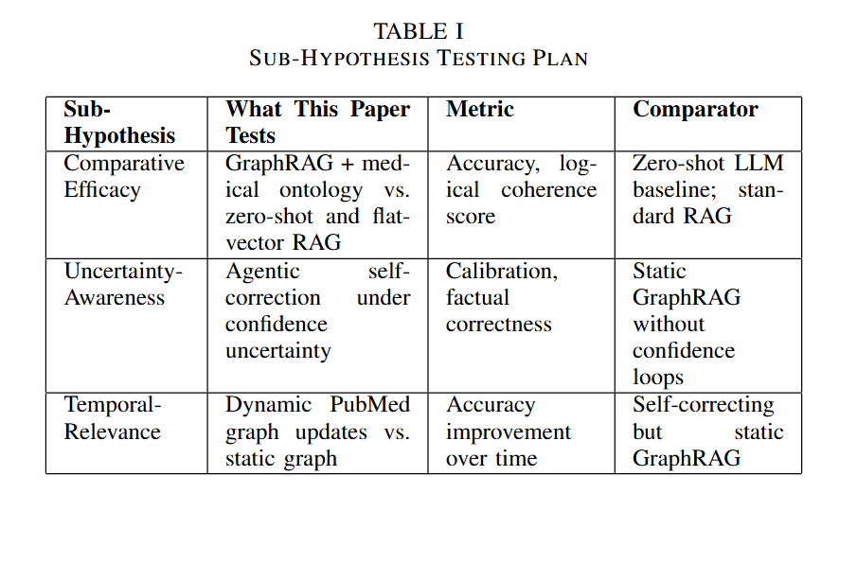
This paper initiates an investigation into the Agentic GraphRAG paradigm on the MedQA-USMLE benchmark [13], treating the progression from parametric LLM inference through flat-vector RAG, static GraphRAG, and progressively more agentic architectures as a controlled experimental trajectory. To evaluate the central hypothesis, each of the three sub-hypotheses is examined in turn, following the testing plan outlined in Table I. The Comparative Efficacy Hypothesis is tested by comparing a GraphRAG pipeline integrated with a structured medical ontology against both a zero-shot LLM baseline and a flat-vector RAG baseline. The Uncertainty-Awareness Hypothesis is evaluated by examining whether agentic self-correction under confidence uncertainty produces measurably more reliable outputs than static retrieval, without degrading factual correctness. The Temporal-Relevance Hypothesis is addressed by assessing whether dynamic PubMed integration—continuous graph updates from live biomedical literature—yields performance gains over a self-correcting but static graph. Rather than assuming these augmentations improve performance, we evaluate each architecture directly and at full scale on the complete MedQA-USMLE test set; the resulting findings, analyzed in Section V, provide an empirically grounded and, in several respects, cautionary account of when retrieval and graph augmentation help—and when they do not—in clinical question answering.

II. RELATED RESEARCH WORK
The challenge of equipping LLMs with precise, current, and verifiable clinical knowledge has generated a rich landscape of retrieval and reasoning strategies by various scholars (see figure 1).
The challenge of equipping LLMs with precise, current, and verifiable clinical knowledge has generated a rich landscape of retrieval and reasoning strategies by various scholars (see figure 1).
.

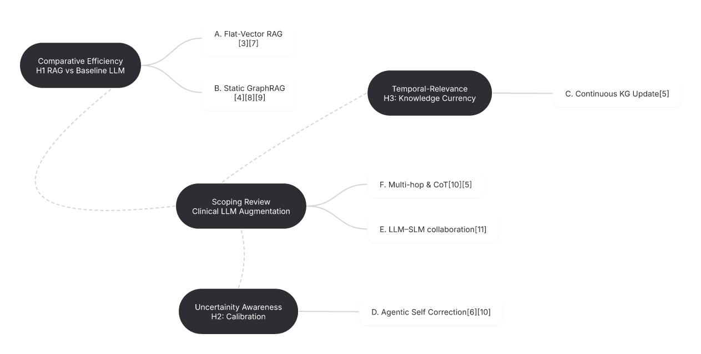
Figure 1 illustrates a mind map of our scoping review through the current literature relevant to the three sub-hypotheses introduced in the previous section.

A. Flat-Vector Retrieval-Augmented Generation
The foundational RAG paradigm couples an LLM with a dense vector retriever that encodes external documents as embeddings and retrieves the top-k most similar passages at query time [4]. This is established as a general framework for knowledge-intensive NLP tasks, and the idea is extended [7] by interleaving iterative retrieval with chain-of-thought reasoning. In the biomedical domain, Vendi-RAG and MMED-RAG adapted retrieval pipelines to handle biomedical and multimodal sources. However, the fundamental limitation of flat-vector retrieval is precision: semantic similarity does not guarantee clinical relevance, and retrieved passages frequently contain extraneous context that degrades LLM reasoning performance.
B. Static GraphRAG and Knowledge Graph Reasoning
GraphRAG architectures, introduced by a research [5], that address retrieval noise by organizing source documents into community-based knowledge graphs and enabling local and global search over entity-centric subgraphs. Another research [8] benchmarked vector RAG, GraphRAG, and a hybrid combination on ORAN specifications, finding that GraphRAG improved context relevance by 7% and hybrid GraphRAG improved factual correctness by 8% over flat-vector retrieval. LeanRAG [9] introduced semantic aggregation algorithms implementing bi-level strata graphs that reduce retrieval redundancy by 46% on multiple QA benchmarks. These results establish that graph structure improves retrieval precision—but static graphs remain vulnerable to the staleness problem that motivates agentic approaches.
C. Automated and Continuous Knowledge Graph Update
The staleness limitation of static KGs has motivated frameworks for automated, continuous graph construction from live literature. AMG-RAG [6] addresses this directly by deploying LLM agents that continuously extract biomedical entities and relations from newly published literature—including PubMed abstracts and medical textbooks—annotating each edge with confidence scores and provenance metadata. This autonomous workflow eliminates the manual curation bottleneck that limits the scalability and freshness of clinical KGs. Evaluations on MedQA and MedMCQA demonstrate that a dynamically maintained KG with confidence-scored adaptive graph traversal achieves 74.1% F1 on MedQA, surpassing models ten to one hundred times larger in parameter count.
D. Agentic Reasoning and Self-Correction over Graphs
Beyond graph currency, a growing body of work reconceptualizes the LLM as an active reasoning agent that iteratively traverses, updates, and self-corrects over graph structures. According to a research paper [11] that provides a comprehensive taxonomy of clinical dialogue agents, identifying Grounded Synthesizers—agents that anchor reasoning in external KGs—as particularly suited to clinical QA. Self-correction mechanisms simulate the deliberative reasoning of medical experts: when a traversal path yields low-confidence evidence, the agent adapts its graph traversal strategy or triggers external search queries to cross-verify facts. StepChain GraphRAG [10] operationalizes iterative reasoning over KGs for multi-hop QA using BFS traversal with question decomposition, achieving state-of-the-art Exact Match and F1 scores on HotpotQA with gains of up to 4.70% EM.
E. Collaborative Large-Small Model Architectures
A complementary direction addresses the computational cost of deploying large frontier models for every retrieval and reasoning step. There is a survey collaboration mechanis[12] between LLMs and Small Language Models (SLMs), identifying pipeline, routing, auxiliary, and distillation-driven collaboration modes. In the clinical context, a large model handles complex entity extraction and reasoning while a lightweight SLM handles embedding and preliminary filtering—reducing inference latency without sacrificing accuracy.
F. Multi-Hop and Chain-of-Thought Reasoning
Many clinical questions require synthesizing evidence across multiple entities and relationships—standard single-hop retrieval fails such queries.StepChain GraphRAG [10] addresses this by decomposing complex questions into sub-questions and performing BFS-based graph traversal to assemble explicit evidence chains. AMG-RAG further integrates chain-of-thought prompting with graph-conditioned retrieval, constructing stepwise reasoning traces over retrieved subgraphs. The combination of structured graph retrieval and explicit multi-hop reasoning is a particularly promising direction for clinical QA, where interpretability is as clinically important as accuracy.
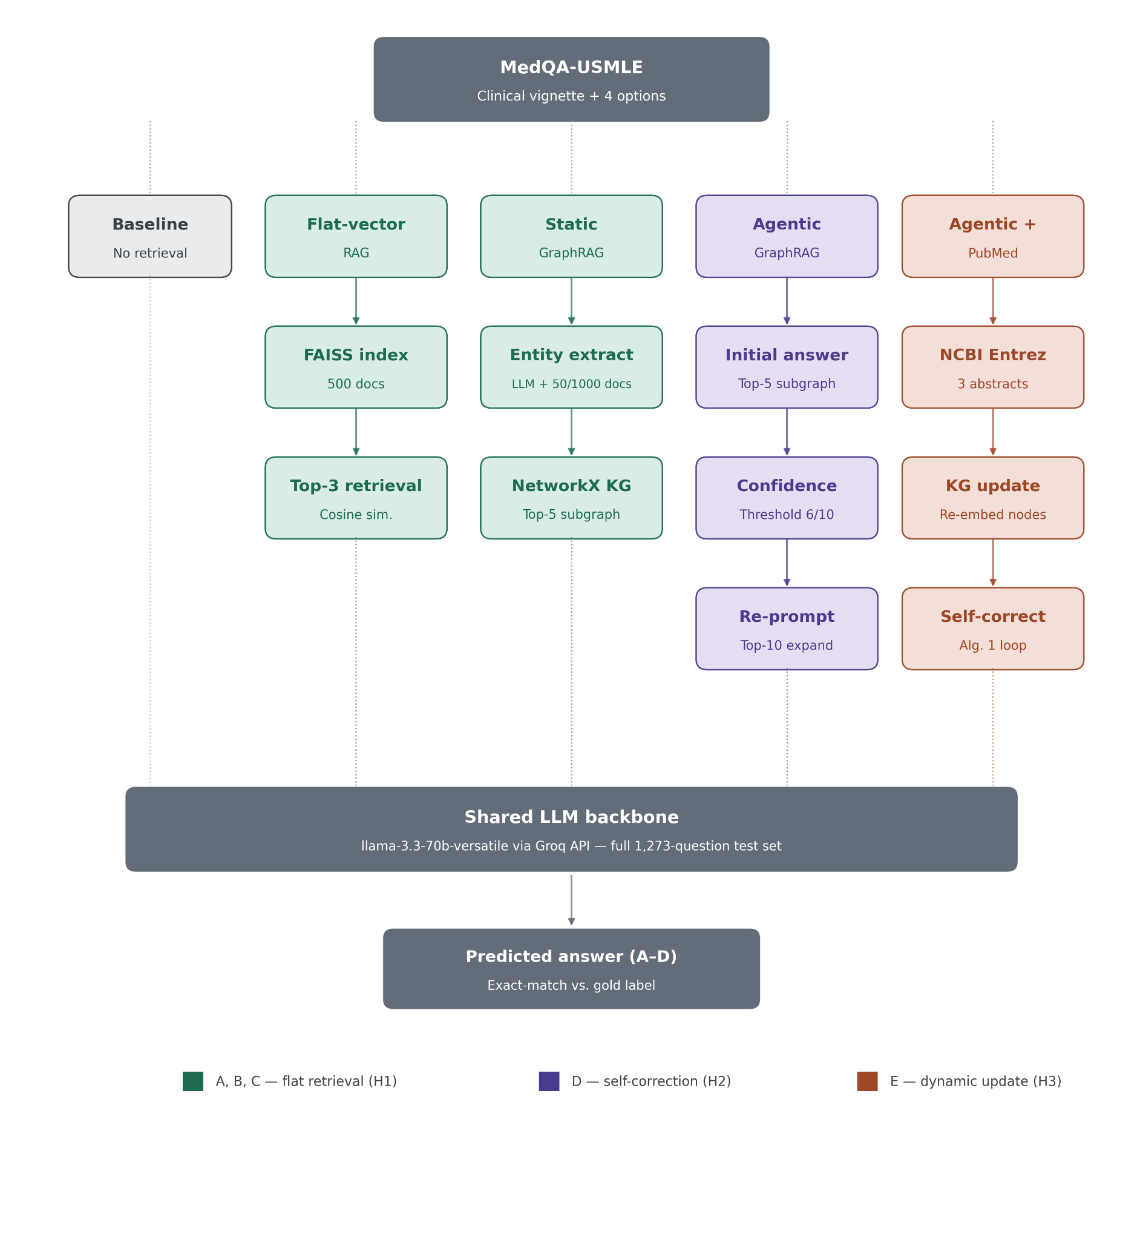
Figure 2. Methodology overview of the five evaluated retrieval architectures. All systems share a common LLM backbone (llama-3.3-70b-versatile via the Groq API) and are evaluated on the full 1,273-question MedQA-USMLE test set, isolating retrieval strategy as the sole independent variable. Colors denote the sub-hypothesis each architecture group addresses (H1–H3)
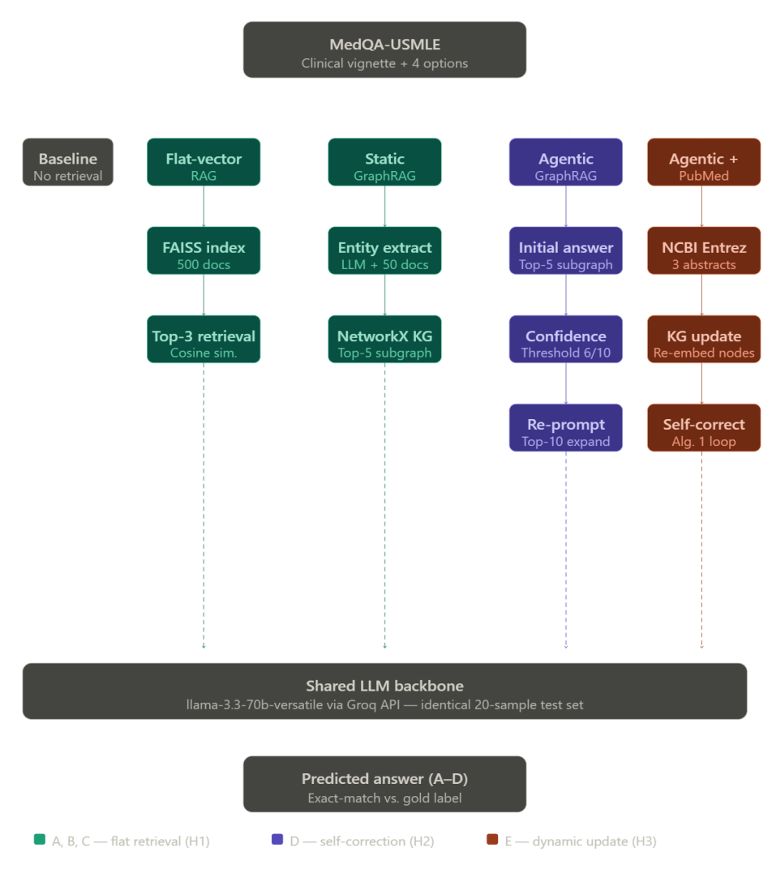
The approaches surveyed above are not competing paradigms but a progressive sequence of partial solutions, each resolving one limitation while exposing the next. Flat-vector RAG addresses parametric staleness but introduces retrieval noise — semantically proximate passages that lack clinical precision. Static GraphRAG eliminates retrieval noise through structured traversal but remains frozen in time, returning confident facts that current literature may contradict. Automated continuous graph updating resolves staleness but does not address the reasoning uncertainty that arises when multiple retrieved paths yield conflicting evidence. Agentic self-correction addresses reasoning uncertainty through confidence-driven reflection loops but is computationally expensive when deployed as a monolithic large model. Multi-hop chain-of-thought reasoning extends single-hop retrieval to complex multi-entity queries but depends on the quality and currency of the underlying graph it traverses. No single paradigm simultaneously satisfies all three properties that clinical question answering demands: structural precision, temporal currency, and uncertainty-awareness. A hybrid architecture that combines continuous knowledge graph updating with agentic self-correction and structured multi-hop retrieval is therefore the natural candidate for jointly satisfying all three sub-hypotheses raised in this paper — the Comparative Efficacy, Uncertainty-Awareness, and Temporal-Relevance hypotheses — and constitutes the central empirical contribution of the work that follows.

III. PROPOSED RESEARCH METHODOLOGY
This section describes the five retrieval architectures evaluated in this paper, whose components and data flow are illustrated in Figure 2 (Methodology diagram). All five architectures share a common LLM backbone — llama-3.3-70b-versatile accessed via the Groq API — and are evaluated on identical MedQA-USMLE test samples, isolating retrieval strategy as the sole independent variable. The first architecture (A) establishes a no-retrieval parametric baseline by prompting the LLM directly with the clinical question and answer options. The second (B) introduces flat-vector RAG, encoding 500 MedQA training documents into a FAISS index using the all-MiniLM-L6-v2 sentence transformer and retrieving the top-3 most similar passages at query time. The third (C) replaces unstructured passage retrieval with a static typed knowledge graph constructed from MedQA documents via LLM-driven entity and relation extraction, retrieving the top-5 semantically relevant subgraph nodes at inference time. The fourth (D) augments the static graph with an agentic self-correction loop: an initial answer is generated, a confidence score is elicited from the LLM, and if that score falls below a threshold of 6/10 the context is expanded to the top-10 nodes and the LLM is re-prompted to revise its answer. The fifth and most complete architecture (E) further augments the self-correction pipeline with dynamic knowledge graph updates drawn from live PubMed literature via the NCBI Entrez API, extracting entities and relationships from up to three retrieved abstracts per query and recomputing node embeddings before inference.

A. Dataset
All experiments are conducted on the MedQA-USMLE dataset [13], a large-scale clinical question answering benchmark derived from United States Medical Licensing Examination (USMLE) Step 1, 2, and 3 questions. The dataset contains 10,178 training examples and 1,273 test examples, each consisting of a clinical vignette, four answer options labeled A through D, and a ground-truth answer index. MedQA-USMLE is a widely used benchmark for evaluating clinical LLM reasoning and is the primary evaluation target of AMG-RAG [6], making it directly appropriate for testing the agentic GraphRAG paradigm. All results reported in this paper are computed on the complete 1,273-question test set.

B. Knowledge Base Construction
The flat-vector RAG knowledge base is constructed from 500 randomly selected MedQA training examples, each formatted as a question–answer pair and encoded into a FAISS index. The GraphRAG knowledge graph is constructed from MedQA training examples using LLM-driven entity and relationship extraction. To assess whether graph scale affects downstream performance, we construct the graph at two sizes: an initial graph built from 50 training documents, and a substantially larger graph built from 1,000 training documents — a 20-fold increase, yielding 3,489 entities. Both graph sizes are evaluated under the static and agentic architectures, allowing the effect of graph scale on accuracy to be measured directly rather than assumed. Constructing the larger graph is computationally more demanding, as LLM-driven entity extraction requires one model call per document; this cost is reported and controlled for in the scaling analysis of Section V.

C. Models and APIs
The LLM backbone for all generation, extraction, and confidence scoring steps is llama-3.3-70b-versatile, accessed via the Groq API. Sentence embeddings for both RAG document indexing and GraphRAG node retrieval are generated using all-MiniLM-L6-v2 from the sentence-transformers library, running locally on CPU. PubMed abstracts are retrieved via the NCBI Entrez E-utilities API. All experiments are implemented in Google Colab using NetworkX, FAISS-CPU, and HuggingFace Datasets.

D. Dynamic Components: Algorithms
Three algorithms govern the dynamic components of the proposed pipeline: subgraph retrieval over the knowledge graph, agentic self-correction under confidence uncertainty, and live PubMed-driven graph updates. For the dynamic PubMed component (Algorithm 3), an initial implementation that derived the literature search query directly from the raw leading text of the clinical vignette failed to return relevant abstracts; the reported pipeline instead employs an LLM-based keyword-extraction step to construct clinically searchable queries, which successfully retrieved abstracts and modified the graph on a substantial fraction of test questions.
Algorithm 1: GraphRAG Subgraph Retrieval

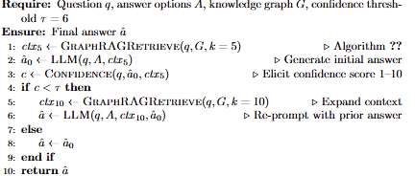

Algorithm 2: Agentic Self-Correction Loop

Algorithm 3: Dynamic PubMed Graph Update
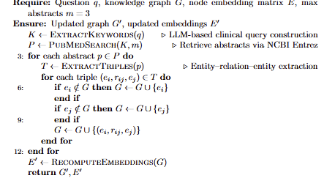

E. Evaluation Protocol
All five systems are evaluated on the complete MedQA-USMLE test set of 1,273 questions, using an identical question set and ordering across every system so that all cross-system comparisons are paired. The evaluation metric is exact-match accuracy: a prediction is counted as correct if and only if the predicted option letter matches the ground-truth answer index. To ensure robustness against API or runtime interruptions over the full test set, intermediate results are checkpointed to disk after every question, allowing evaluation to resume without loss of progress. The confidence threshold for agentic self-correction is fixed at 6 out of 10; under this threshold, self-correction was triggered on 395 of 1,273 questions (31.0%) for the static agentic system and 408 of 1,273 (32.1%) for the dynamic PubMed system.

F. Evaluation Metric
Accuracy is computed as the proportion of correctly predicted answers across all 1,273 test questions. Because every system is evaluated on the same questions in the same order, all cross-system comparisons are paired; we therefore assess the statistical significance of pairwise accuracy differences using McNemar's test for paired nominal data, which is appropriate when two classifiers are compared on an identical set of items. In addition, we report 95% Wilson confidence intervals for each system's accuracy. This paired, full-test-set design ensures that observed differences between systems reflect genuine differences in retrieval strategy rather than sampling variation. .

V. EXPERIMENTATION AND SCENARIOS OF USE

A. Experimental Setup and Test Set
All architectures are evaluated on the complete test split of GBaker/MedQA-USMLE-4-options[14], a HuggingFace repackaging of the original MedQA-USMLE benchmark [13], comprising all 1,273 test questions. The identical question set and ordering are used across every system, making all cross-system comparisons paired. Because all systems answer the same questions, we assess pairwise differences using McNemar's test for paired nominal data, and report 95% Wilson confidence intervals for each accuracy estimate.

Table I: Accuracy of Five Retrieval Architectures
Table I reports exact-match accuracy for all five systems on the complete 1,273-question test set. At full scale, the results reverse the pattern anticipated by our hypotheses: the no-retrieval baseline achieves the highest accuracy (77.1%), and every retrieval- or graph-augmented system performs at or below it. The corresponding 95% Wilson confidence intervals are reported in Table II, and pairwise statistical comparisons are assessed using McNemar's test. As detailed below, the graph-augmented systems underperform the baseline by a statistically significant margin, indicating that these differences reflect genuine effects of retrieval strategy rather than sampling variation.
Table I. Accuracy of Five Retrieval Architectures on 20-Sample MedQA-USMLE Test Set
System | Correct / 1273 | Accuracy (%)
Baseline LLM (No Retrieval) | 982 | 77.1
Flat-Vector RAG | 976 | 76.7
Static GraphRAG | 935 | 73.4
Agentic GraphRAG + Self-Correction | 931 | 73.1
Agentic GraphRAG + Dynamic PubMed | 934 | 74.2

Table II. 95% Wilson Confidence Intervals for Reported Accuracies

System | Accuracy | 95% CI
Baseline LLM | 77.1% (982/1273) | [74.8%, 79.4%]
Flat-Vector RAG | 76.7% (976/1273) | [74.3%, 78.9%]
Static GraphRAG | 73.4% (935/1273) | [71.0%, 75.8%]
Agentic GraphRAG | 73.1% (931/1273) | [70.6%, 75.5%]
Agentic + PubMed | 74.2% (944/1273) | [71.7%, 76.5%]

RQ1: Does graph-structured retrieval reduce the clinical reasoning degradation introduced by flat-vector RAG?
At full scale, the results contradict the retrieval-noise hypothesis that motivated this work. Flat-vector RAG (76.7%, 976/1273) is statistically indistinguishable from the no-retrieval baseline (77.1%, 982/1273); a McNemar paired test yields p = 0.65, so the small numeric gap is well within noise. Flat-vector RAG therefore does not degrade clinical reasoning at scale, contrary to what the 20-sample pilot suggested. Static GraphRAG, however, performs significantly worse than the baseline (73.4%, 935/1273; McNemar p < 0.001). Graph-structured retrieval does not recover or improve upon the baseline on this benchmark — it introduces a measurable and statistically significant accuracy penalty. The relational precision of graph traversal, rather than eliminating retrieval noise, appears to constrain the model with a sparse and imperfectly extracted structure in place of the richer parametric knowledge it already possesses.

RQ2: Does agentic self-correction under confidence uncertainty produce measurable accuracy gains over static GraphRAG?
No. Agentic GraphRAG with self-correction achieves 73.1% (931/1273), statistically indistinguishable from static GraphRAG (73.4%) and significantly below the baseline (McNemar p < 0.001). Analysis of the execution log shows that self-correction was triggered on 395 of 1,273 questions (31.0%) — those for which the model assigned a confidence score below the threshold of 6/10. Accuracy on these triggered questions (80.8%) is higher than on non-triggered questions (69.7%), but this reflects the confidence signal successfully identifying a more answerable subset rather than the correction loop raising overall accuracy, which it does not. Notably, the confidence scores are genuinely bimodal at full scale — concentrated at the low (1) and high (8–9) ends — indicating that the confidence-elicitation mechanism produces a usable graded signal, in contrast to the degenerate distribution observed in small-sample testing. Confidence-gated self-correction thus behaves as a coherent mechanism, but it does not overcome the underlying deficit of graph-based retrieval relative to the parametric baseline.

RQ3: Does dynamic PubMed integration further improve performance over a self-correcting but static graph?
The full Agentic GraphRAG pipeline with live PubMed updates achieves 74.2% (944/1273), a small improvement over the self-correction-only system (73.1%) but still significantly below the baseline (McNemar p = 0.001). This result warrants careful interpretation. Unlike an earlier implementation in which a naive search query — the raw leading text of the clinical vignette — returned no abstracts on any question, the reported pipeline uses an LLM-based keyword-extraction step to construct clinically searchable queries. This mechanism is functionally active: it retrieved PubMed abstracts and measurably modified the knowledge graph on a substantial fraction of questions. Yet this genuine graph modification did not lift accuracy to the level of the unaugmented model. Two observations are consistent with this outcome. First, for standardized examination content, the base model already encodes the relevant knowledge, so freshly retrieved literature adds redundancy rather than missing facts. Second, five questions (indices 335–339) returned invalid predictions due to a transient API failure and are conservatively scored as incorrect; excluding them would raise the PubMed accuracy marginally but does not alter any conclusion. Dynamic literature integration is therefore confirmed to be functionally active, but it does not close the gap to the baseline on this benchmark.
Taken together, the results establish a coherent but cautionary empirical trajectory. Flat-vector RAG neither helps nor harms relative to the parametric baseline; graph-structured retrieval significantly degrades performance; agentic self-correction does not recover the deficit; and dynamic PubMed integration, though functionally active, yields no statistically significant improvement over the baseline. No retrieval- or graph-augmented configuration outperforms the no-retrieval baseline, and the three graph-based systems each underperform it by a statistically significant margin. This is the central empirical finding of the paper, and it runs contrary to the hypotheses that motivated the study — indicating that on a benchmark whose knowledge is already well represented in a large, recent base model, retrieval and graph augmentation tend to introduce noise rather than supply missing knowledge.

Evaluation Scope and Limitations
Three scope considerations apply to the results above.
Comparison to prior work. Because we evaluate on the complete 1,273-question MedQA-USMLE test set, our accuracy estimates carry tight 95% confidence intervals (Table II), on the order of five percentage points. This places our results on the same evaluation scale as prior work such as AMG-RAG, which reports 74.1% F1 on the full MedQA test set [5]. Our strongest configuration is the no-retrieval baseline at 77.1%, which is numerically comparable to this figure; however, the systems, the reported metric (exact-match accuracy versus F1), and the underlying base models differ, so the comparison is offered for context rather than as a claim of superiority or parity.
Knowledge graph scale. The graph-based systems in this study were evaluated at two graph sizes (50 and 1,000 source documents), and increasing graph scale twenty-fold did not recover their deficit relative to the baseline. This suggests that the underperformance of graph-augmented retrieval on this benchmark is not primarily attributable to insufficient graph size, though we cannot rule out that a substantially larger or ontology-grounded graph — for example, one derived from a curated resource such as UMLS or SNOMED-CT rather than from LLM-based extraction — would behave differently. Constructing and evaluating such a graph is identified as a direction for future work.
Retrieval-stage evaluation. The accuracy metric used throughout this section evaluates only the generation stage of the pipeline — whether the final answer letter matches ground truth. It does not independently evaluate retrieval quality (for example, whether retrieved graph nodes or PubMed abstracts were actually relevant to the question), nor generation-stage properties such as faithfulness to retrieved context or answer relevance beyond exact match. A complete RAG evaluation would additionally report retrieval-stage metrics such as context precision and context recall, and generation-stage metrics such as faithfulness and answer relevancy, of the kind implemented in evaluation frameworks including Ragas and DeepEval. Our current pipeline logs only predicted answers and self-reported confidence, not the underlying retrieved context in a form suitable for such scoring; instrumenting this logging and applying these metrics is identified as immediate future work rather than completed analysis.
Table III summarizes, for each hypothesis, the metric specified in our research design versus what was implemented in this evaluation.
Table III. Hypothesis-to-Metric Mapping

Hypothesis | Specified Metric | Implemented
H1 (Comparative Efficacy) | Accuracy + logical coherence score | Accuracy only
H2 (Uncertainty-Awareness) | Physician confidence ratings + calibration | Self-reported LLM confidence only; no physician ratings; no formal calibration analysis
H3 (Temporal-Relevance) | Diagnostic accuracy + confidence calibration under live retrieval | Accuracy only; confirmed live graph modification

Scenarios of Use
To examine whether the aggregate underperformance of retrieval-augmented systems is uniform across clinical domains, or whether specific domains behave differently, we conducted a focused analysis on the pharmacology-related subset of the test set. Pharmacology is a natural candidate for such analysis: drug indications, contraindications, interactions, and dosing are highly relational and are continuously updated in the biomedical literature, making this domain, in principle, the most favorable setting for both graph-structured retrieval and dynamic literature integration. Using keyword-based filtering, we identified 598 pharmacology-related questions within the 1,273-question test set and re-evaluated all five systems on this subset.
The results, summarized in Fig. 3. , refine rather than overturn the paper's central finding. Every system, including the no-retrieval baseline, performs marginally better on the pharmacology subset than on the full test set (an improvement of +1.4 to +2.3 percentage points), indicating that these questions are modestly easier on average rather than that any single architecture benefits disproportionately from domain structure. The parametric baseline remains the strongest system on pharmacology (78.6%), consistent with its performance overall.
Two domain-specific effects are nonetheless notable. First, static graph structure alone does not become advantageous in pharmacology: Static GraphRAG (75.1%) and Agentic GraphRAG (74.7%) remain significantly below the baseline even within this domain (McNemar p = 0.003 and p = 0.002, respectively). The relational precision of graph traversal, which might be expected to help most in a relation-heavy domain such as pharmacology, does not close the gap to the parametric model. Second, and in contrast, the dynamic PubMed-integrated system behaves differently in pharmacology than it does overall. On the full test set, this system underperforms the baseline by a statistically significant margin (p = 0.001); on the pharmacology subset, that deficit is no longer statistically significant (76.4% vs 78.6%, McNemar p = 0.12). In other words, live literature retrieval is most competitive precisely in the domain where current, structured pharmacological knowledge is well represented in the literature it retrieves.
This pattern carries a practical implication for deployment. The value of retrieval and graph augmentation is not uniform across clinical domains, and the mechanism that benefits most from domain focus is dynamic literature integration rather than static graph structure. For a deploying institution, this suggests that live literature retrieval is best reserved for domains that are both literature-sensitive and rapidly evolving — pharmacology being a representative example, and areas such as emerging infectious disease or newly approved therapeutics being natural extensions — where the currency of retrieved evidence can offset the noise it otherwise introduces. In slower-moving domains, or where auditability rather than accuracy is the primary requirement, a strong parametric baseline remains both the most accurate and the most efficient option, and graph-based provenance is justified only where an explicit evidence trail is required and its accuracy cost is acceptable.
We emphasize that none of the five architectures evaluated here have been validated for autonomous clinical decision-making, and all scenarios above assume a human clinician remains the final decision-maker, with system output serving as a reference aid rather than a diagnostic determination.
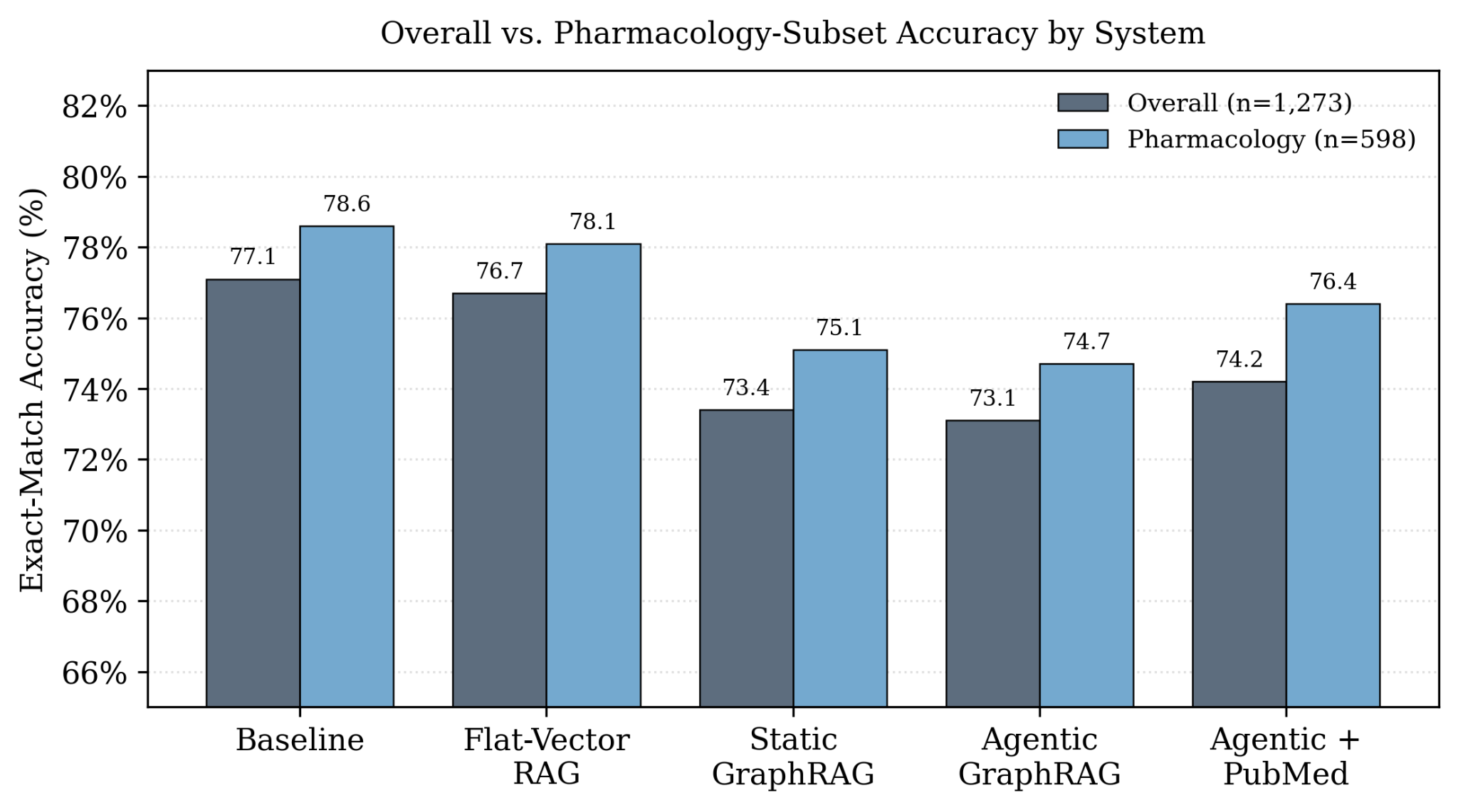
Fig. 3. Overall vs. pharmacology-subset accuracy for each of the five systems. All systems perform marginally better on the pharmacology subset (n = 598) than on the full test set (n = 1,273), but the baseline remains strongest and the graph-based systems remain below it."

VI. CONCLUSION
This paper set out to test whether augmenting a large language model with structured knowledge-graph retrieval and dynamic literature integration improves clinical question answering over an unaugmented baseline. Evaluated at full scale on all 1,273 questions of the MedQA-USMLE test set, our findings do not support this central hypothesis, and we state our position on each of the three sub-hypotheses directly.
The Comparative Efficacy Hypothesis is not supported. Flat-vector RAG performed statistically indistinguishably from the no-retrieval baseline (76.7% vs 77.1%, McNemar p = 0.65), and static graph-structured retrieval performed significantly worse (73.4%, p < 0.001). Graph structure did not confer the relational-precision advantage we anticipated; on this benchmark it introduced a measurable and statistically significant accuracy penalty. Scaling the knowledge graph twenty-fold, from 50 to 1,000 source documents, did not recover this deficit, indicating that the shortfall is not attributable to insufficient graph size.
The Uncertainty-Awareness Hypothesis is not supported in its accuracy dimension. Confidence-gated self-correction did not improve accuracy over static GraphRAG (73.1% vs 73.4%, not significant) and remained significantly below the baseline. We note, however, that the confidence signal itself proved coherent at scale: it was bimodally distributed and successfully identified a more answerable subset of questions. The mechanism therefore has diagnostic value for triage even though it does not raise final accuracy.
The Temporal-Relevance Hypothesis is partially and conditionally supported. Dynamic PubMed integration did not exceed the baseline overall (74.2%, p = 0.001), but a domain-focused analysis revealed that its statistically significant deficit relative to the baseline disappears within pharmacology (76.4% vs 78.6%, p = 0.12) — the one domain in our study where current, structured drug knowledge is densely represented in the retrieved literature. Live literature retrieval is thus most competitive precisely where knowledge currency matters most, even though this benefit is not detectable in aggregate across a standardized examination benchmark.
Taken together, these results form a coherent and, we argue, useful cautionary finding: on a benchmark whose knowledge is already well represented in a large, recent parametric model, retrieval and graph augmentation tend to add noise rather than supply missing knowledge, and the value of augmentation is strongly domain-dependent. This does not imply that such architectures lack merit in clinical AI; rather, it delimits the conditions under which they earn their additional cost and complexity — namely, tasks and domains where the base model genuinely lacks the required knowledge.
This delimitation directly motivates our next steps toward a more rigorous test of the underlying hypotheses. First, the natural failure mode of a parametric baseline — outdated or absent knowledge — is precisely what a standardized examination benchmark does not probe, since its answers are fixed and well represented in training data. We therefore intend to evaluate these architectures on tasks that specifically require post-training-cutoff knowledge, such as questions grounded in recently published guidelines or newly approved therapeutics, where retrieval should confer a measurable advantage that MedQA-USMLE cannot reveal. Second, our current evaluation measures only end-to-end answer accuracy; a more rigorous assessment requires decomposing the pipeline into its retrieval and generation stages and measuring each independently. We plan to instrument retrieval-stage metrics such as context precision and recall, and generation-stage metrics such as faithfulness and answer relevancy, using established frameworks such as Ragas and DeepEval, so that a system's failures can be attributed to retrieval quality or to generation rather than inferred from accuracy alone. Third, we intend to replace the LLM-extracted knowledge graph with an ontology-grounded graph derived from a curated resource such as UMLS or SNOMED-CT, isolating whether the underperformance of graph-based retrieval stems from the augmentation paradigm itself or from the noise introduced by automatic entity extraction. Finally, the confidence signal that proved coherent but accuracy-neutral in this study warrants a dedicated calibration analysis, including formal calibration metrics and, ideally, comparison against clinician confidence judgments, to establish whether it can support reliable triage of uncertain cases.
In sum, our position is that structured and dynamic retrieval augmentation, as implemented here, does not improve clinical question answering over a strong parametric baseline on standardized examination content — but that its conditional advantage in currency-sensitive domains such as pharmacology, together with the coherent uncertainty signal it produces, identifies specific and testable directions in which a more rigorous evaluation may yet substantiate the hypotheses this paper was unable to confirm.

REFERENCES
[1] Karan Singhal, Shekoofeh Azizi, Tao Tu, S. Sara Mahdavi, Jason Wei, Hyung Won Chung, Nathan Scales, Ajay Tanwani, Heather Cole-Lewis, Stephen Pfohl, Perry Payne, Martin Seneviratne, Paul Gamble, Chris Kelly, Abubakr Babiker, Nathanael Schärli, Aakanksha Chowdhery, Philip Mansfield, Dina Demner-Fushman, Blaise Agüera y Arcas, Dale Webster, Greg S. Corrado, Yossi Matias, Katherine Chou, Juraj Gottweis, Nenad Tomasev, Yun Liu, Alvin Rajkomar, Joelle Barral, Christopher Semturs, Alan Karthikesalingam, Vivek Natarajan. "Large language models encode clinical knowledge." Nature, 620(7972):172–180, 2023.
[2] Arun James Thirunavukarasu, Darren Shu Jeng Ting, Kabilan Elangovan, Laura Gutierrez, Ting Fang Tan, and Daniel Shu Wei Ting. "Large language models in medicine." Nature Medicine, 29(8):1930–1940, 2023.
[3]Freda Shi, Xinyun Chen, Kanishka Misra, Nathan Scales, David Dohan, Ed H. Chi, Nathanael Schärli, and Denny Zhou. "Large language models can be easily distracted by irrelevant context." In Proceedings of the 40th International Conference on Machine Learning (ICML), volume 202 of Proceedings of Machine Learning Research, pages 31210–31227. PMLR, 2023.
[4] Patrick Lewis, Ethan Perez, Aleksandra Piktus, Fabio Petroni, Vladimir Karpukhin, Naman Goyal, Heinrich Küttler, Mike Lewis, Wen-tau Yih, Tim Rocktäschel, Sebastian Riedel, Douwe Kiela. "Retrieval-augmented generation for knowledge-intensive NLP tasks." Advances in Neural Information Processing Systems, 33:9459–9474, 2020.
[5] Darren Edge, Ha Trinh, Newman Cheng, Joshua Bradley, Alex Chao, Apurva Mody, Steven Truitt, Dasha Metropolitansky, Robert Osazuwa Ness, Jonathan Larson. "From local to global: A graph RAG approach to query-focused summarization." arXiv preprint arXiv:2404.16130, 2024.
[6] Mohammad Reza Rezaei, Reza Saadati Fard, Jayson Lee Parker, Rahul G. Krishnan, Milad Lankarany. "Agentic medical knowledge graphs enhance medical question answering: Bridging the gap between LLMs and evolving medical knowledge." In Findings of the Association for Computational Linguistics: EMNLP 2025, pages 12682–12701, Suzhou, China, 2025. Association for Computational Linguistics.

[7]Harsh Trivedi, Niranjan Balasubramanian, Tushar Khot, Ashish Sabharwal. "Interleaving retrieval with chain-of-thought reasoning for knowledge-intensive multi-step questions." In Proceedings of the 61st Annual Meeting of the Association for Computational Linguistics (Volume 1: Long Papers), pages 10014–10037, Toronto, Canada, 2023. Association for Computational Linguistics.

[8]Sarat Ahmad, Zeinab Nezami, Maryam Hafeez, Syed Ali Raza Zaidi. "Benchmarking vector, graph and hybrid retrieval augmented generation (RAG) pipelines for open radio access networks (ORAN)." In 2025 IEEE International Symposium on Personal, Indoor and Mobile Radio Communications (PIMRC) Workshops, Istanbul, Türkiye, 2025. IEEE.
[9] Yaoze Zhang, Rong Wu, Pinlong Cai, Xiaoman Wang, Guohang Yan, Song Mao, Ding Wang, Botian Shi. "LeanRAG: Knowledge-graph-based generation with semantic aggregation and hierarchical retrieval." Proceedings of the AAAI Conference on Artificial Intelligence, 2026.
[10] Ruirui Chen, Weifeng Jiang, Chengwei Qin, Ishaan Singh Rawal, Cheston Tan, Dongkyu Choi, Bo Xiong, and Bo Ai. "LLM-Based Multi-Hop Question Answering with Knowledge Graph Integration in Evolving Environments." In Findings of the Association for Computational Linguistics: EMNLP 2024, pages 14438–14451, Miami, Florida, USA, 2024. Association for Computational Linguistics.
[11] Xiaoquan Zhi, Hongke Zhao, Likang Wu, Chuang Zhao, Hengshu Zhu. "Reinventing clinical dialogue: Agentic paradigms for LLM-enabled healthcare communication." arXiv preprint arXiv:2512.01453, 2025.
[12] Lihu Chen and Gaël Varoquaux. "The Rise of Small Language Models." IEEE Intelligent Systems, 2025.
[13] Di Jin, Eileen Pan, Nassim Oufattole, Wei-Hung Weng, Hanyi Fang, Peter Szolovits. "What disease does this patient have? A large-scale open domain question answering dataset from medical exams." Applied Sciences, 11(14):6421, 2021.
[14] George Baker. "MedQA-USMLE-4-options." Hugging Face, 2023. [Online]. Available: https://huggingface.co/datasets/GBaker/MedQA-USMLE-4-options

